Chapter 10-[2-way Bounding](https://mfleck.cs.illinois.edu/building-blocks/version-1.3/bounding.pdf)

Monday, January 2, 2023

12:23 AM

***2-Way Bounding:***

Create bounds from both directions to ensure the accuracy of a proof. (Using 2 sub proofs)

For example: to prove F(x) = k, we can prove F(x) ≥ k **and** F(x) ≤ k.

*(kind of like sandwich/squeeze theorem, Calc 2 moment)*

***Markers*** are used to mark out outlines of things to cut out (cookie dough, cloth for clothing, etc.)

*Need to be as efficient as possible.*

Things like markers cannot be calculated directly, but through 2-way bounding, sometimes we can make a ***Tight*** bound and make the upper and lower bounds meet.

*2-Way Bounding is helpful when trying to prove that there is a maximum or minimum of something.*

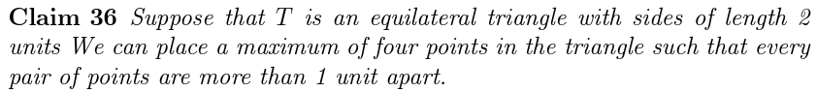

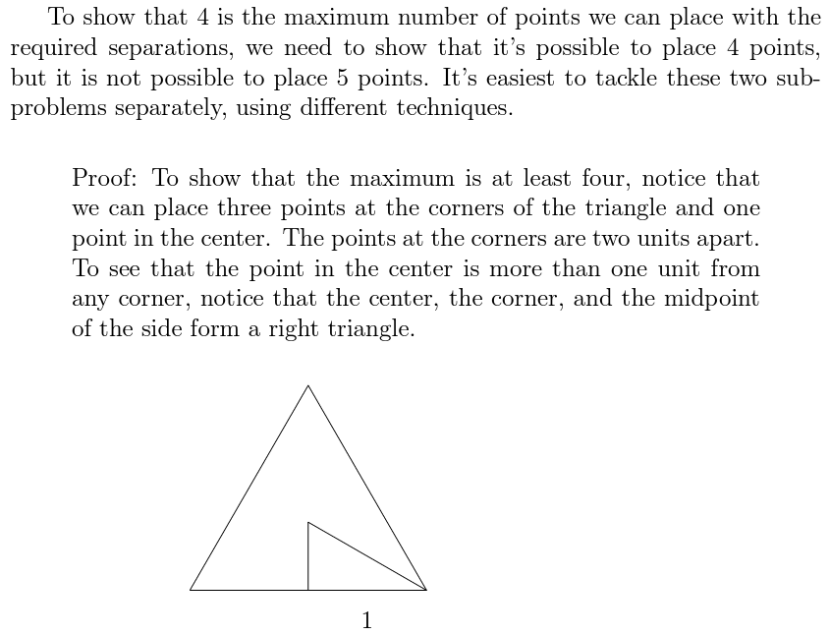

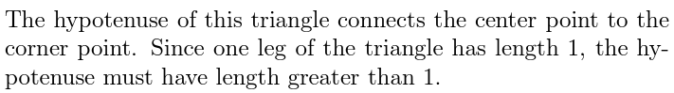

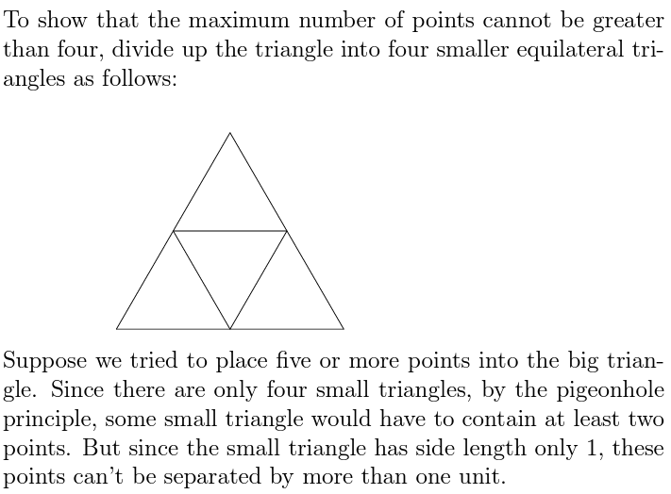

The *Coloring* of a graph assigns a color to each node of G but two adjacent nodes cannot be the same color.

If G can be colored with k colors, we say G is *k-colorable.*



is the smallest number of colors needed to color G.

*A complete graph of Kn requires n colors, since all nodes are adjacent to each other.*

Coloring is often used to optimize algorithms. For example, in code compiling, each variable is considered a node at compile time, and the colors available are the register available. When 2 variables(nodes) need to be used at the same time, they cannot be assigned the same color (register), so we connect them with an edge. As we assign colors (registers), we try to use as little different colors (registers) as possible, and take out nodes(variables) if necessary to optimize the compiling process.

2-way bounding proofs are also used to prove that two sets are equal.





